Beyond technical potential: profitability, robustness, and regional sustainability trade-offs in mature cogeneration pathways for palm oil mill residues
Keywords (draft, to refine): palm oil mill residues; biomass valorization; mixed-integer optimization; distributed self-generation; profitability disparities; carbon abatement cost
Abstract
Prior assessments of Colombia's palm oil residual biomass have established the scale of its technical energy potential but have stopped short of determining whether capturing that potential is a financially sound decision for the mills that would need to invest in it. This study moves beyond potential quantification to assess profitability, robustness, and sustainability trade-offs across two mature cogeneration pathways, both already partially adopted within the Colombian palm sector: an extraction condensation steam turbine paired with biogas generation from palm oil mill effluent, and a backpressure steam turbine paired with biogas generation from co-digested effluent and thermally pretreated empty fruit bunches. A mixed integer optimization model is developed for six extraction plants in the Magdalena department, jointly assessing economic, environmental, and social outcomes under both pathways. Both routes are found to be profitable without subsidy, even at full technical deployment, yielding annual net benefits of USD 1.96 million and USD 6.33 million respectively. Yet neither route dominates across all three sustainability dimensions: the backpressure and co-digestion pathway offers higher and more robust profitability, tolerating a 70% electricity price collapse compared to 13% for the extraction condensation pathway, while the latter avoids substantially more emissions in absolute terms. Plant level results, masked in prior regional aggregate assessments, reveal that profitability is concentrated in the two largest mills, leaving the smallest mill unviable under either route. Furthermore, at current prices, neither pathway is privately optimal at full deployment; closing that gap costs USD 225 to 392 per additional tonne of CO2 avoided, far exceeding Colombia's current carbon tax and indicating limited capacity of that instrument to close the gap on its own.

Introduction
Colombia's oil palm agroindustry generates large volumes of residual biomass, including empty fruit bunches, fiber, shell, and palm oil mill effluent, whose energy content is widely regarded as an underexploited resource for the country's renewable energy transition and for strengthening electricity access in rural, biomass-producing regions. Establishing exactly how much of this technical potential can realistically be captured, and through which technological route, remains an open and consequential question.
Converting technical potential into installed capacity, however, is not automatic. Bioenergy generation is a discretionary investment that sits outside the core business of a palm oil extraction plant, which is the production of crude palm oil. Committing capital to on site power generation exposes a mill to a different set of risks, including electricity market prices, regulatory conditions governing self generation and surplus exchange, and technology specific costs, none of which are relevant to the mill's primary operations. From the perspective of an individual investor, the relevant question is therefore not whether generating electricity from residual biomass is technically feasible or environmentally desirable, both of which are increasingly well established, but whether it is sufficiently and robustly profitable to justify entering an unfamiliar line of business. From a system perspective, however, more renewable generation is unambiguously beneficial: it strengthens grid robustness, displaces fossil generation, and supports national decarbonization and rural electrification targets, regardless of whether the private return fully reflects that value.
This tension between what is privately optimal and what is technically and environmentally optimal has received limited attention in the literature on palm biomass valorization. Prior techno-economic assessments have typically reported aggregate, departmental level profitability using a single representative technology, without disaggregating results across individual mills or testing their robustness to electricity price uncertainty. As a result, two practically important questions remain unanswered. First, does profitability hold uniformly across mills of different sizes and operating conditions, or is it concentrated in a subset of plants, with implications for whether policy support, if any, should be broad or targeted. Second, how large is the gap between the deployment level a private investor would rationally choose and full technical deployment, and what would closing that gap cost in terms of forgone private profitability.
This study addresses both questions using two cogeneration pathways that are technologically mature and already partially adopted within the Colombian palm sector: an extraction condensation steam turbine paired with biogas generation from palm oil mill effluent, and a backpressure steam turbine paired with biogas generation from co-digested effluent and thermally pretreated empty fruit bunches. A mixed integer optimization model is developed for six extraction plants in the Magdalena department, jointly assessing economic, environmental, and social outcomes under both pathways. The analysis quantifies the technical energy potential of the region's residual biomass, evaluates plant level profitability and its robustness to electricity price fluctuations, and estimates the cost, in forgone private profitability, of moving from the privately optimal deployment level to full technical deployment. In doing so, this study reframes the relevant policy question from whether this transition needs to be subsidized to which technological route policy should favor, and for which mills targeted intervention may be warranted.

Materials and methods
This study assesses whether the deployment of residual biomass in palm oil mills is constrained by biomass availability, by market and regulatory conditions, or by the technological route selected. A multi-objective mixed-integer linear programming (MILP) model was built in Python 3 using the Pyomo algebraic modelling library and solved with the GLPK solver. The model was parameterized with primary operational data from six palm oil mills and used to generate Pareto fronts of profitability against biomass deployment; the levelized cost of electricity (LCOE), the greenhouse gas balance, and rural electricity coverage were subsequently evaluated at every point of each front. All data cleaning, modeling, and post-processing steps are implemented in openly available Jupyter notebooks (see Data availability).

Study area and biomass characterization
This study covers six palm oil mills (Plants A to F) located in the Magdalena department, on the Caribbean coast of Colombia. Primary data were collected in the field during the authors' doctoral research and comprise process flows, steam and electricity consumption by processing stage, biomass yields, fuel use, and equipment inventories. Nominal processing capacities range from 20 to 40 tonnes of fresh fruit bunches per hour, and actual annual throughput ranges from 38,620 to 206,200 tonnes, reflecting substantial heterogeneity in scale and utilization across the sample (Table 1). Annual operating hours also vary widely, from 1,931 hours per year at Plant F to 5,920 hours per year at Plant C; this difference turns out to matter a great deal for profitability, as Section 4.2 shows.
Table 1 Plant characterization and annual biomass availability
Plant | Capacity (t FFB/h) | Hours (h/yr) | FFB processed (t/yr) | Shell (t/yr) | Fiber (t/yr) | EFB (t/yr) | POME (m3/yr)
A | 30 | 5,105 | 153,150 | 9,189 | 18,837 | 37,215 | 91,890
B | 40 | 5,155 | 206,200 | 8,496 | 25,775 | 46,395 | 123,720
C | 30 | 5,920 | 177,600 | 7,992 | 22,555 | 40,670 | 106,560
D | 24 | 5,496 | 131,904 | 7,519 | 16,356 | 24,534 | 79,142
E | 30 | 3,147 | 94,410 | 3,444 | 12,368 | 22,979 | 56,646
F | 20 | 1,931 | 38,620 | 2,703 | 4,905 | 8,245 | 23,172

The original spreadsheets, laid out with one column per plant for ease of reading, were restructured into a tidy long format, with each row recording a single parameter, its unit, the processing stage, the plant, and the corresponding value, so that the dataset could be queried programmatically by the optimization model. Eleven processing stages were normalized across the six mills: reception, sterilization, threshing, digestion and pressing, clarification, oil recovery, storage, nut drying, nut cracking, process water heating, and the boiler house. Data quality was audited rather than assumed: a unit error in the reported lower heating value of the biomass, an analogous unit error in the CH4 emission factor applied to the valorization scenarios, and a set of process efficiencies computed by a spreadsheet formula with a broken reference were identified and corrected before modeling; in each case the affected quantities were recomputed from first principles and the reported efficiencies were treated as model outputs subject to validation rather than as inputs.
The higher heating value of each biomass fraction was obtained from its ultimate analysis (Table 3, #13). Boiler efficiency was computed with the direct method of the ASME performance test code, with steam and feedwater enthalpies from the IAPWS-IF97 formulation; for the Plant A baseline this yielded 75.7%, consistent with the 54 to 76% range measured across the sector.

Current energy configuration
At present, two of the six plants already operate on site power generation: Plant A meets 79.1% of its electricity demand through existing steam cogeneration, and Plant D meets 70.0% of its demand through an existing biogas system; the remaining four plants rely entirely on grid supply for electricity (Table 2). Process thermal demand, in contrast, is met entirely from each mill's own boiler in all six cases; there is no grid substitute for process steam. It is 13.5 to 26.4 times larger than electricity demand, which is typical for a process this steam intensive. This existing infrastructure is treated as a baseline condition rather than as a modeled investment in either scenario, and its implications for the marginal investment case of Plants A and D are examined separately in Section 3.4.
Table 2 Current (baseline) energy configuration
Plant | Electricity consumption (MWh/yr) | Electricity self-generation (%) | Self-generation source | Thermal demand (kWth) | Thermal energy demand (MWh_th/yr)
A | 3,083.7 | 79.1 | Steam cogeneration (existing) | 11,627.4 | 59,357.9
B | 5,398.1 | 0.0 | Grid only | 14,954.1 | 77,088.2
C | 2,740.9 | 0.0 | Grid only | 12,199.8 | 72,222.8
D | 3,746.2 | 70.0 | Biogas (existing) | 9,180.4 | 50,455.2
E | 2,281.7 | 0.0 | Grid only | 10,323.7 | 32,488.7
F | 702.9 | 0.0 | Grid only | 7,436.5 | 14,360.0

System boundary and scenario definitions
The system boundary is drawn at the mill gate. Only the incremental investment associated with energy valorization is considered: boilers, turbines, flue gas treatment, anaerobic digesters, biogas engines, and the process substitutions they require. The existing extraction plant is assumed to operate identically across all cases and is therefore excluded from both capital and operating costs, as are the revenues of the core oil extraction business, which do not change with the energy configuration. Combustion of biogenic carbon is treated as climate neutral following IPCC convention; only CH4 and N2O from combustion, together with fossil diesel use, are accounted as emissions.
Three configurations are compared. The baseline reproduces the mills' measured current operation, in which low pressure boilers supply process steam and electricity is drawn from up to three sources: on site biomass cogeneration where it exists, the national grid, and back up diesel generation. The baseline is not a design case but a validation case, used to confirm that the model reproduces the plants' measured energy balances before either scenario is evaluated (Section 2.4).
Scenario 1 (extraction condensation route) combusts all solid residues, fiber, shell, and mechanically pretreated empty fruit bunches, in a high pressure boiler. An extraction condensation steam turbine bleeds steam to satisfy process heat demand and expands the remainder to condensing conditions to maximize electricity output. Palm oil mill effluent is anaerobically digested and the resulting biogas fuels a gas engine; empty fruit bunches are not part of this digestion stream. Continuous sterilization replaces the conventional batch process in this scenario.
Scenario 2 (backpressure route with co-digestion) combusts only fiber and shell, in a lower pressure boiler feeding a backpressure turbine whose exhaust steam supplies the entire process heat demand. Empty fruit bunches are withdrawn from the combustion train, thermally pretreated to raise their biodegradability, and co-digested with palm oil mill effluent, so that the anaerobic route carries a substantially larger organic load than in Scenario 1. Continuous sterilization is not implemented in this scenario: the additional steam demand it requires could not be met by the energy available from the reduced solid biomass stream (fiber and shell only), so the conventional batch process is retained. Dynamic clarification, which does not add steam demand, replaces the conventional stage in both scenarios.
Design parameters for the boilers and turbines follow operating conditions reported for comparable installations, with the Scenario 2 turbine parameters verified against Booneimsri et al. (2018). The biochemical methane potential of pretreated EFB was computed with the correlation of Thomsen et al. (2014), and the conceptual design assumptions for organic load removal, biogas yield, and CH4 content were taken from Voogt et al. (2021).

Optimization model
The model was developed in two phases.
Phase 1 (validation) formulates each configuration with fixed capacities and no degrees of freedom, using a dummy objective; its purpose is to confirm that the thermal balance and the electricity balance close simultaneously for each mill before any decision variable is introduced. All three configurations returned optimal status for the six mills, confirming the internal consistency of the cleaned dataset.
Phase 2 (superstructure) releases equipment capacity as a decision variable. Two generation routes are represented independently for each mill: a steam turbine selected from a discrete commercial catalogue by binary variables, and a modular biogas engine sized as an integer number of 1,000 kW units, a modularity consistent with units reported for palm oil mill effluent to biogas installations. Each route carries its own continuous utilization factor, bounded between zero and one. Biomass availability is the binding physical constraint: no route may generate more energy than its substrate allows.
Surplus electricity is not remunerated at a single price. Under the prevailing Colombian regulation for distributed and small scale self generation, each kWh is valued according to its destination, in decreasing order of value: self consumption, which displaces retail purchases at the plant's own weighted electricity price (0.114 to 0.259 USD/kWh, computed from each mill's measured supply mix); an energy credit tier up to the plant's own consumption, remunerated at the same retail price; and any excess above that, sold at the spot price (0.0703 USD/kWh, the eleven month average of the wholesale market, adopted because of the high volatility of the series). Because tier prices are strictly decreasing, the model allocates generation to the higher value tiers first without requiring additional binary variables (Table 3, #5).
Table 3 Governing equations for optimization model
# | Component | Formula (draft) | Notes
1 | Equipment CAPEX (six-tenths rule) | C = C_ref × (S / S_ref)^0.6 × CEPCI_2026/CEPCI_2019 | CEPCI 2019 = 607.5, CEPCI 2026 ≈ 873.8
2 | Modular biogas generator CAPEX | C_biogas = n_units × C_unit | Linear, 1,000 kW increments
3 | Annualized CAPEX | C_ann = C_total / PVAF | PVAF = 8.5136 (10% discount rate, 20-year lifetime)
4 | O&M cost | O&M = 0.025 × C_total | Applies to both variable and fixed CAPEX
5 | Three-tier revenue | Revenue = auto×p_retail + permuta×p_retail + bolsa×p_spot | permuta capped at own demand; p_spot = 0.0703 USD/kWh
6 | Objective 1 (economic benefit) | f1 = Revenue − C_ann − O&M − opportunity cost | Opportunity cost of displaced biomass fuel use
7 | Objective 2 (generation) | f2 = Σ (turbine + biogas generation) × hours | Gross generation; self-consumption constant across front, §53
8 | ε-constraint sweep | max f1 s.t. f2 ≥ ε, ε over 10 intervals | Pareto front construction
9 | LCOE (export basis, CORRECTED) | LCOE = (C_ann + O&M) / export_kWh | Corrected this session; was generation basis
10 | HHV correlation | HHV = 0.3443C + 1.192H − 0.113O − 0.024N + 0.093S | C,H,O,N,S on dry mass basis; internal consistency check only
11 | Avoided emissions balance | ΔGHG = biomass + biogas non-CO2 − grid displacement credit + diesel backup | Biogenic CO2 excluded (IPCC); diesel EF = 74,100 kg CO2/TJ; grid EF = 163.4 g CO2/kWh
12 | Rural household-equivalent | HH_served = min(export_kWh / 346, total_rural_users) | 346 kWh/household/yr, 3.7 persons/household (DANE 2018); capped at 100%; non-saturating share-of-total-demand indicator reported alongside
13 | Boiler efficiency | Direct method, ASME PTC, IAPWS-IF97 enthalpies | Plant A baseline: 75.7%, within 54-76% sector range

Regulatory framework represented in the model
Three families of instruments govern the economics of distributed bioenergy in Colombia, and the model represents them asymmetrically, a choice made explicit here because it conditions the interpretation of the results.
CREG Resolution 174 of 2021, which governs remuneration of surplus electricity, is the only instrument embedded in the optimization itself: it acts on the marginal revenue of each additional kWh and therefore on the sizing decision, and its tariff structure is described in Section 2.4. Capital side tax incentives for non-conventional renewable sources (Law 1715 of 2014, as amended by Law 2099 of 2021) are deliberately not represented in the base case; the economic results reported in Section 3 are therefore conservative by construction, and the magnitude of this omission is quantified separately in the sensitivity analysis of Section 2.9. Two further instruments, the firm energy reliability charge (CREG Resolution 071 of 2006) and the current carbon tax (Decree 926 of 2017), are treated as context rather than embedded in the optimization; both are assessed against the model outputs in the Discussion.

Techno-economic parameters
Capital costs are derived from supplier quotations obtained during the study, referenced to a 15 t FFB/h capacity, and escalated to 2026 USD using the Chemical Engineering Plant Cost Index (Table 3, #1). Where no quotation was available, costs were scaled from a reference capacity using the six-tenths rule (Table 3, #1; exponent 0.6), which replaces an earlier, invalid linear CAPEX assumption in which boiler cost was inadvertently double counted with turbine cost. Investments are annualized with a present value annuity factor of 8.5136, corresponding to a 10% discount rate over a 20 year lifetime (Table 3, #3), and operating and maintenance costs are taken as 2.5% of capital cost per year (Table 3, #4), applied to both fixed and variable CAPEX.
A distinction is made between capital costs that respond to the sizing decision, the steam turbine and the biogas engine, and those that do not, such as the boiler, flue gas treatment, digester lagoons, and process substitutions, which are dimensioned by the plant's throughput rather than by the capacity chosen. Only the former enter the solver's objective, since the latter cannot alter the optimal solution; both, however, are included in the net benefit reported in the results, so that profitability is assessed against the full incremental investment.

Sustainability indicators
Three indicators, the levelized cost of electricity, the greenhouse gas balance, and rural electricity coverage, are computed at every point of the Pareto front rather than at a single design point.
The LCOE is calculated as annualized capital cost plus annual operating and maintenance cost, divided by the annual electricity exported rather than generated (Table 3, #9). Exported surplus, the electricity that actually leaves the mill and is remunerated or credited under the tariff structure of Section 2.4, is the economically and physically meaningful quantity for this indicator; self consumption, which is fixed by each mill's own demand and does not respond to the sizing decision, is excluded from the denominator to keep the indicator comparable across plants of different demand.
The greenhouse gas balance draws on that same exported surplus. It applies IPCC default emission factors for CH4 and N2O from solid biomass and biogas combustion, an emission factor of 74,100 kg CO2/TJ for backup diesel, and a credit for the displacement of grid electricity by the exported surplus (Table 3, #11). A carbon uptake credit of the palm plantation is reported separately, since it is common to all configurations and would otherwise obscure the comparison between technologies.
Rural electricity coverage expresses that same surplus as an equivalent number of rural households, using the departmental average rural consumption (346 kWh per household per year, derived from Cabello Eras et al. 2022) and 3.7 persons per household (DANE, CNPV 2018) (Table 3, #12). Because a single mill can exceed the aggregate rural residential demand of the entire department, the indicator is capped at 100% coverage for reporting, and a second, non-saturating indicator, the surplus as a share of total departmental electricity demand, is reported alongside it.

Multi-objective framework
A preliminary structural analysis showed that the environmental and social objectives are nearly collinear with electricity generation in this system: avoided emissions scale approximately linearly with exported electricity, and rural coverage scales linearly with the surplus. The only genuine conflict is therefore between economic performance and biomass deployment, and the problem is formulated in two dimensions: f1 (maximize annual net benefit: self consumption savings plus surplus revenue across the three regulatory tiers, minus annualized capital cost and operating cost; Table 3, #6) and f2 (maximize annual electricity generated from biomass, a joint proxy for the environmental and social pillars and a direct answer to how much of the available potential is used; Table 3, #7). Generation, rather than exported energy, is used for f2 because self consumption is constant across the entire explored front (verified this session, §53); this does not affect any reported economic or environmental figure, all of which use exported energy directly.
The Pareto front is obtained with the two step epsilon constraint method (Table 3, #8). A lexicographic payoff table first establishes the extremes of each objective; f1 is then maximized subject to a progressively increasing floor on f2, with the floor varied over 10 intervals between those extremes. The epsilon constraint method was preferred over weighted sum aggregation because it controls the number of efficient solutions, does not skip non-convex regions of the front, and avoids arbitrary normalization of objectives expressed in different units.

Policy instrument analysis
Two further analyses were performed on the converged model, to assess the two families of policy instruments available to Colombian policy on their own terms rather than in the abstract. Both re-solve the full optimization rather than post-processing its outputs, keeping the sizing decision free to respond.

Capital side instruments: a generic effective reduction of capital cost (0%, 10%, 19%, and 30%) is applied to both fixed and variable CAPEX, and the epsilon constraint procedure re-run in full at each level; the 0% case reproduces the base results exactly and serves as a verification of the procedure

Results

Deployment relative to the baseline
The scale of the change from current operation is substantial at every plant, whichever route is followed (Table 4). Under the baseline, four mills draw their electricity entirely from the grid and two already partially self-generate (Table 2); under either scenario, all six become net electricity producers at the economic optimum, generating between four and twenty times their own current consumption.
The size of that jump differs by plant and by scenario in a pattern that reappears throughout the results. Plant D, which already meets 70% of its demand from an existing biogas system, shows the smallest multiple under Scenario 1 (4.1 times its baseline consumption) but a larger one under Scenario 2 (7.0 times); Plant A shows the opposite pattern, with its multiple highest under Scenario 1 (14.7 times) and markedly lower under Scenario 2 (8.6 times). This asymmetry, examined further in Section 3.5, foreshadows why existing infrastructure affects the investment case of the two plants differently depending on which route is chosen.

Table 4 Generation at the economic optimum relative to baseline electricity consumption
Plant | Baseline consumption (MWh/yr) | Scenario 1 generation (MWh/yr) | Scenario 1, multiple of baseline | Scenario 2 generation (MWh/yr) | Scenario 2, multiple of baseline
A | 3,083.7 | 45,261.1 | 14.7x | 26,518.5 | 8.6x
B | 5,398.1 | 62,932.4 | 11.7x | 37,111.0 | 6.9x
C | 2,740.9 | 53,810.2 | 19.6x | 32,405.0 | 11.8x
D | 3,746.2 | 15,192.4 | 4.1x | 26,106.0 | 7.0x
E | 2,281.7 | 8,617.1 | 3.8x | 18,095.2 | 7.9x
F | 702.9 | 3,641.5 | 5.2x | 7,241.2 | 10.3x

Aggregate techno-economic Pareto front
Both scenarios are profitable across their entire Pareto front, from the economic optimum through full technical deployment, with no subsidy required at any point. At the economic optimum, Scenario 1 generates 189.5 GWh per year and Scenario 2 generates 147.5 GWh per year, with net benefits of USD 4,156,715 and USD 7,241,802 respectively; at full deployment, generation rises to 249.1 and 161.6 GWh per year, with net benefits of USD 1,964,312 and USD 6,334,963. Scenario 2 therefore generates less electricity in absolute terms but delivers a substantially higher net benefit throughout the front. LCOE at the economic optimum, on an exported energy basis (Section 2.7), is 0.0797 USD/kWh for Scenario 1 and 0.0526 USD/kWh for Scenario 2; the corresponding avoided emissions are 27,785 and 21,354 tonnes of CO2 per year.

Figures 1 and 2 show how generation is routed through the three revenue tiers of Section 2.4, at the economic optimum and at full deployment, for each scenario. In Scenario 1, POME biogas generation is identical at both points (64.2 GWh/yr): it is already at the ceiling set by effluent availability at the economic optimum, so the entire increase in generation toward full deployment (from 125.2 to 184.9 GWh/yr) comes from the turbine. Scenario 2 shows a related but distinct pattern: biogas generation is nearly constant (127.4 to 127.9 GWh/yr, +0.4%) while turbine generation grows sharply (20.1 to 33.7 GWh/yr, +67.7%), reflecting that Scenario 2's biogas stream co-digests EFB alongside POME and therefore has some, though limited, room to expand with deployment, unlike Scenario 1's POME-only stream. In both scenarios, as deployment rises, a growing share of output is routed to the spot market tier rather than the energy credit tier, since both self-consumption and the credit tier are capped at each plant's own demand (Section 2.7).
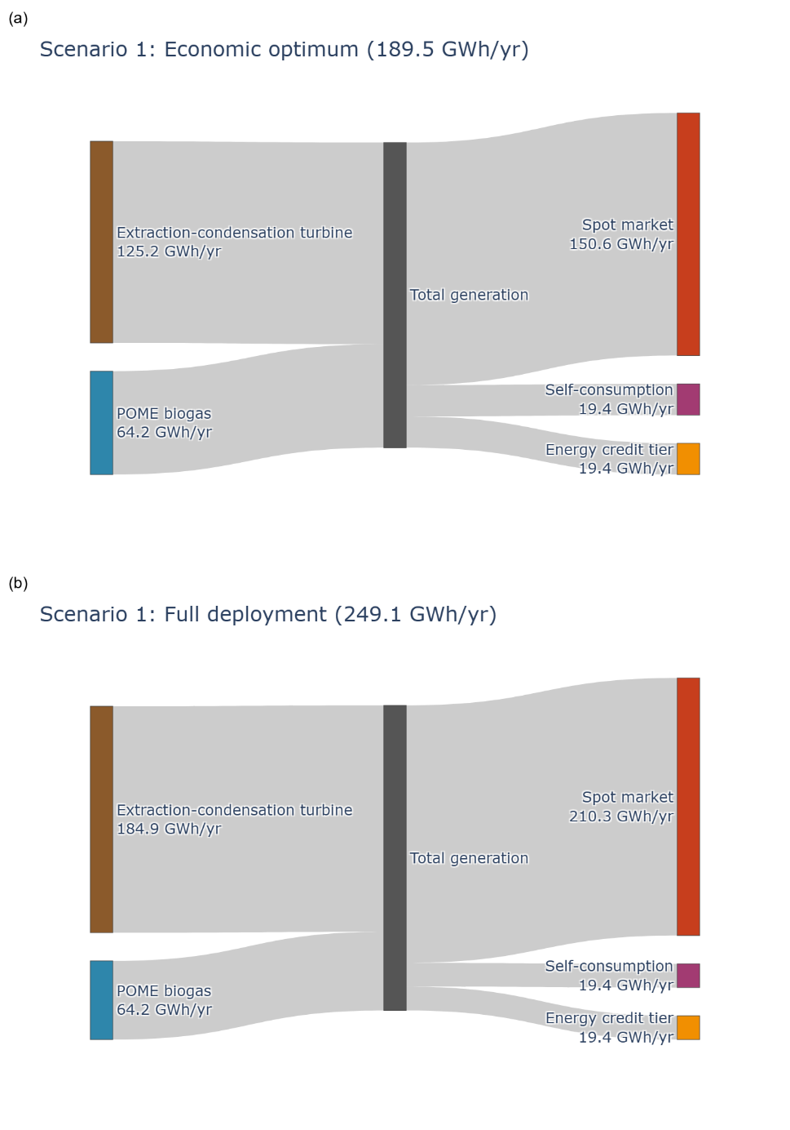
Figure 1 Sankey diagram of Scenario 1 electricity generation routed through the three revenue tiers of Section 2.4, at (a) the economic optimum and (b) full deployment. Node values are annual energy flows, in GWh per year.
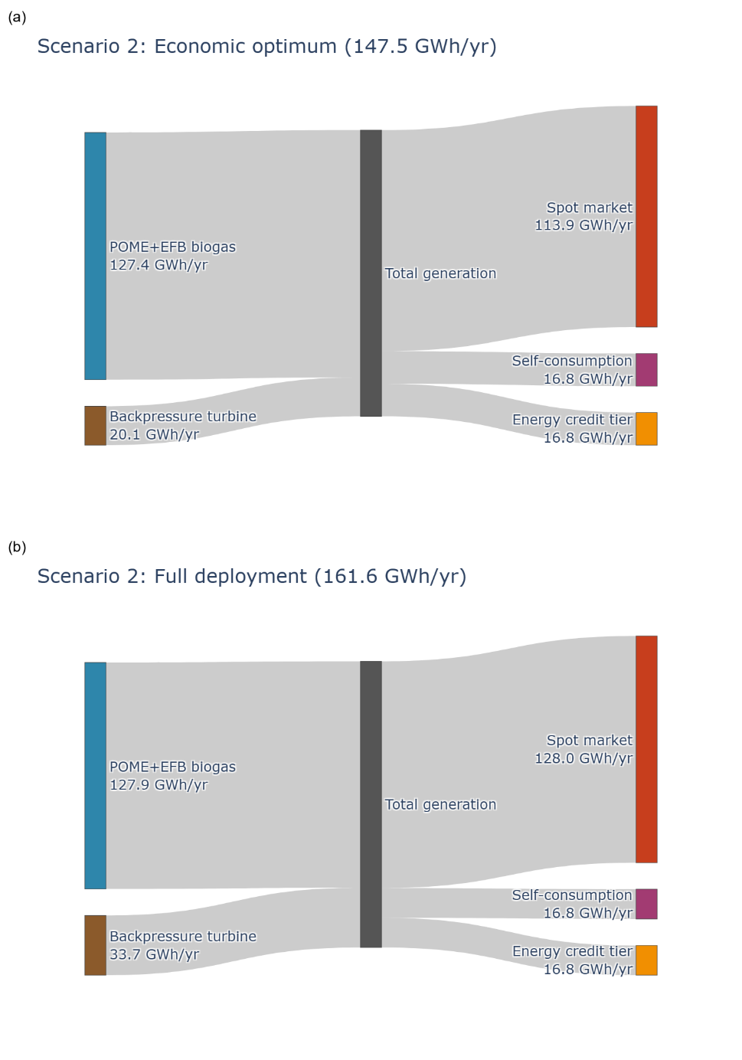
Figure 2 Sankey diagram of Scenario 2 electricity generation routed through the three revenue tiers of Section 2.4, at (a) the economic optimum and (b) full deployment. Node values are annual energy flows, in GWh per year.

